Summary of Christie Gardens data collection so far (February 13, 2018)
33 full data sets so far
28 F, 5 M
-missing age for 1 participant – will get that on Feb 20
-one participant only completed 7 CBS tasks

 | age | MoCA | MMSE | DT | OOO | SP | GR | DS | TS | PA | SS | FM | R | P | ML
min | 70 | 12 | 16 | -6 | 2 | 1 | -1 | 0 | 10 | 2 | 0 | 2 | -11 | -5 | 0
max | 92 | 29 | 30 | 33 | 16 | 28 | 22 | 7 | 10 | 5 | 52 | 110 | 98 | 58 | 8
mean | 82.6 | 24.06 | 27.54 | 7.89 | 8.57 | 11.03 | 10 | 4.66 | 5.56 | 3.40 | 5.91 | 66 | 29 | 14.69 | 5.43

Replication of Brenkel et al 2017
First, I split the participants into three groups based on their MoCA scores:
- Unimpaired: 27-30 (9 participants)
- Borderline: 23-26 (18 participants)
- Impaired: <22 (8 participants)

Second, I looked into further categorizing the borderline group based on their scores in each CBS task. I calculated the mean score for the Impaired and Unimpaired groups and compared each borderline score against those means. This comparison allowed me to determine whether, based on that task alone, the borderline participant could be categorized into the impaired or unimpaired groups.
Some tasks were more useful for further categorizing the borderline groups than others.

Brenkel et al, 2017 found that PA and FM were the least useful in categorizing Borderline participants. This was replicated.
They also found that Double Trouble was one of the most useful for categorizing from the battery they used. This was replicated
 | PA | FM | GR | DS | TS | OOO | ML | R | SP | SS | P | DT
% left in Borderline | 83 | 83 | 72 | 72 | 67 | 61 | 61 | 39 | 39 | 33 | 33 | 22
% moved to Unimpaired | 17 | 17 | 6 | 11 | 11 | 33 | 17 | 17 | 17 | 39 | 39 | 22
% moved to Impaired | 0 | 0 | 22 | 17 | 22 | 6 | 22 | 44 | 44 | 28 | 28 | 56
Question:
Is a single borderline participant always categorized in the same direction?
Answer:
No. Only two participants, when categorized, were always categorized into the impaired group. The rest of the participants in the borderline group were sometimes categorized to impaired and sometimes to unimpaired.

Third, I looked into whether I could perform the same analysis on the MMSE scores.
I could not.
When the scores were divided up according the MMSE guidelines I was left with very uneven groups
- No cognitive impairment 24-30 (31 participants)
- Mild cognitive impairment 18-23 (2 participants)
- Severe cognitive impairment <17 (1 participant)

Regression analysis
In R, I performed a step-wise multiple regression analysis to determine which combination of CBS tasks best predicted both MoCA and MMSE scores.

MoCA
MoCA scores are best predicted by: Feature Match and Token Search
Adjusted R² = 0.64
Age was included as a factor and predicts 8% of the variance in MoCA scores (adjusted R² = 0.077)

MMSE
MMSE scores are best predicted by: Odd One Out and Grammatical Reasoning
Adjusted R² = 0.46
Age was included as a factor and predicts 2% of the variance in MMSE scores (adjusted R² = 0.024)

When both of these regression analyses were performed using Bayesian statistics, the same results were obtained.

Plots showing the relationship between MoCA/MMSE scores and age
The horizontal lines indicate the category cutoffs
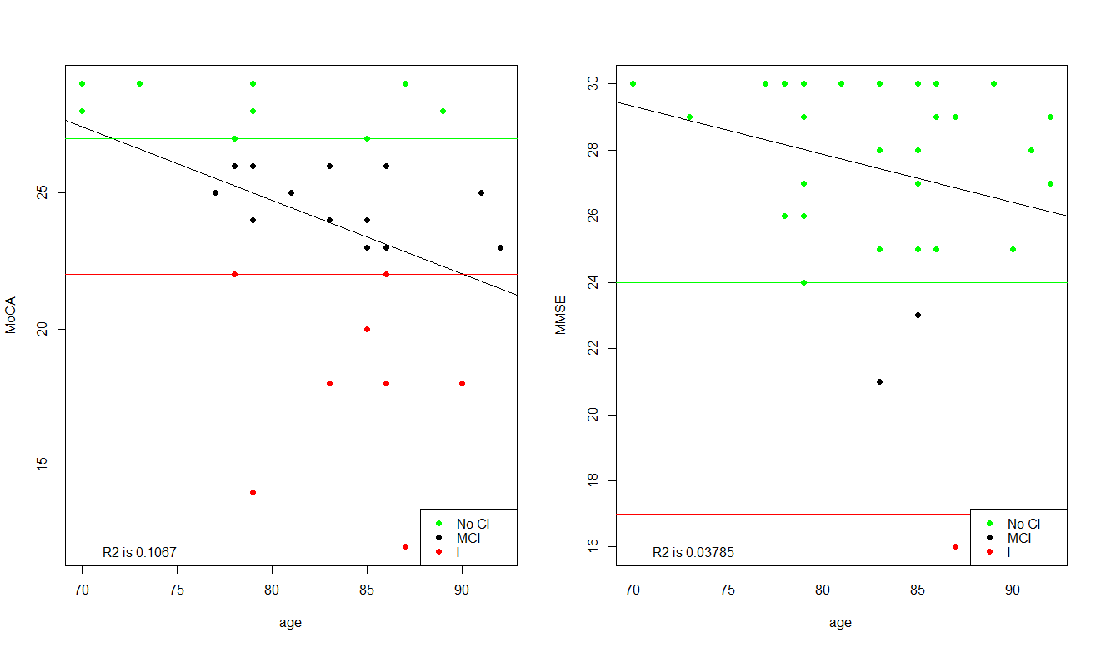
The black line is the trend line and the R² values are in the bottom left
Scatter plots of all CBS task scores vs age
The CBS task scores are not normalized here (that’s why all of the y-axes are different)
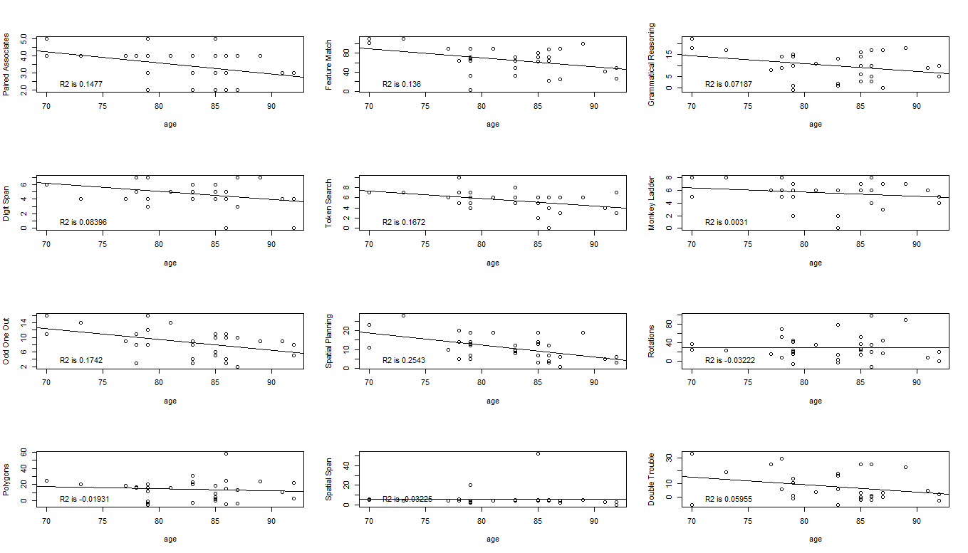
Interestingly, Spatial Span, Rotations, and Polygons do not show an age effect

